[](http://www.google.com.au/url?sa=i&rct=j&q=&esrc=s&frm=1&source=images&cd=&cad=rja&uact=8&ved=0CAcQjRxqFQoTCJL2qKyQh8gCFYeMlAod2SwIXg&url=http://www.google.com.au/url?sa=i&rct=j&q=&esrc=s&frm=1&source=images&cd=&cad=rja&uact=8&ved=&url=http://www.maccyps.sa.edu.au/links-supporters.php&psig=AFQjCNHa66TOAVK9J-ltAvr4D2fvN4KV1w&ust=1442890536131843&psig=AFQjCNHa66TOAVK9J-ltAvr4D2fvN4KV1w&ust=1442890536131843)



**Renmark Primary School**

**Newsletter**

58 Murtho Street, Renmark, SA, 5341 Website: www.renmarkr7.sa.edu.au

Phone: (08) 8586 5737 Email:[dl.0376_info@schools.sa.edu.au](mailto:dl.0376_info@schools.sa.edu.au)

Fax: (08) 8586 4020 Principal: Ms Lyn Bretag

**No 15/2019 Term 4, Week 2 Thursday, 24 October 2019**

⬩ **Respect** ⬩ **Excellence** ⬩ **Self Belief** ⬩ **Trust**

**News from the Principal**

**WELCOME TO OUR NEW FAMILIES AND STUDENTS**

It’s been wonderful to welcome many new students and their families to our school this term.

I know that you’ll thoroughly enjoy getting to know our fantastic students, new teachers and being part of all the learning and special term 4 events. Lovely to have you all at RPS!

Reception: Tyrell

Year 1: Sian and Ekam

Year 2: Oliver, Samara and Thomas

Year 4: Arjun, Faith and Hamish

Year 5: Shamari

Year 6: Isaak

Year 7: Demario

**TERM 4 SPECIAL EVENTS**

**28/11: *Just2Deadly Awards*** at Barmera Primary School to celebrate the achievement and attendance of year 7 and year 12 Aboriginal students as they transition to the next stage of their education, and life after school. I can’t wait to celebrate with our students!

**28-29/11: *Year 7 Orientation visits to RHS,*** the year 7’s are almost at the end of their primary school education and very ready for their next stage as high school students. They’ve connected with Renmark High school in a number of ways throughout the year which helps them to feel more familiar with the school, staff and other students who’ll be joining them in year 8.

We focus on high school being a wonderful, exciting and challenging next step, not something to be scared or worried about. It is perfectly normal for students to wonder about making new friends, being in different classes with different teachers, managing a new timetable….we help them to navigate these changes with a positive mindset and focus on the many new opportunities coming their way. They are ready!

**5/12: *Let’s Celebrate,*** our whole school end of year celebratory concert is always a highlight for students, staff, families and our community. Pop the date in your diary, come along and celebrate 2019, and have a fabulous night.

Information will come home soon. Class items are being organised and teachers will keep you up to date on how that’s going. We don’t expect parents or caregivers to spend money on costumes; most will be what you’ll already have at home, supplemented by items made at school.

**9/12: *Yr 7 Graduation at the Chaffey Theatre, 2.00 – 3.15pm.*** A wonderful celebration of the achievements and successes of our year 7 students. Parents and caregivers are invited to attend; another special diary date.

**2020 CLASS PLANNING**

Planning for 2020 is underway. A great deal of time, thought and consideration of many factors goes into making sure your child is in the best class to meet their academic, social and wellbeing needs.

***If you have any special considerations or requests regarding your child’s 2020 placement, please put them in writing to me by Monday 11th November.***  Such requests may relate to friendships or specific concerns that I need to be aware of. I don’t consider requests for particular teachers; we take many factors into consideration when placing students with teachers; rest assured, we have your child’s very best interests at heart.

***If your family, child/ren are currently attending our school and won’t be in 2020,*** *please let me know in writing as soon as possible and at the latest by* ***Monday 11th November.*** This is very important for our class planning.

***If you know of new families that have or will be moving to Renmark and wish to enrol their child/ren here for 2020,*** please let us know as soon as possible. Enrolments for 2020 are now open for Reception –Year 7 students.

**Pupil Free Day**

**Friday 8 November (wk. 4)**

Staff Professional Development. OSHC is available for care, bookings essential. Please call: 8586 4481



**SRC/ Little Leaders**

This term our whole school focus during our SRC and Little Leaders meetings will be about one of our learning dispositions – PERSISTANCE.

****Perseverance is the ability and self-control that pushes you to work through challenges. Having perseverance means that when you are facing a challenge, you use your mind and your body to overcome it. Perseverance means you are able to wait and work through difficulties, whether they have to do with your mind, your body, or your emotions. It’s important to point out that the definition of perseverance is not “don’t give up no matter what” or “never quit”. Sometimes you’ll do your best but it will still be time to move on to a different goal. However, perseverance is the ability to do your best toward a goal, even though it’s a big challenge.

**Teach Children to Persist**

**By Michael Grose**

***“Persistence and patience have a magical effect before which difﬁculties disappear and obstacles vanish.” - John Quincy Adams***

The ability to persist at a task and see it through to the end is one of the most important success attributes that you can develop in a child. There are numerous times every day when children must persist rather than give in. A young child learning to tie shoelaces must persist. A primary aged student must show determination to ﬁnish tasks and a secondary student needs to work through difﬁculties, particularly those he doesn’t understand or complete right away. They need to be able to persist when work gets hard or life gets tough.

They need the ‘stickability’ to work through difﬁculties and hang in there when things don’t go their way. Some children are more naturally predisposed to persist than others. They have a determined, even competitive streak in their temperament that doesn’t allow them to give in. These children and young people can drive themselves very hard to succeed.

The results of the Australian Temperament Project show that persistence is the one temperamental factor that can be improved over time. Parents and teachers can develop persistence in children and also impede its development by making life too easy for children so that they don’t have opportunities to persist or hang in there. Parents can promote persistence by encouraging their children to keep going and not give in at the slightest hurdle or difﬁculty. Parents can be a sounding board for children’s gripes but they should show conﬁdence in their ability to cope and get through their difﬁculties.

“You can do it” is far more powerful in terms of promoting an attitude of persistence than “If it is a little too hard then try something else.” Let children know that there is a correlation between effort and success. In fact, they need to learn that by GIVING EFFORT they will more than likely experience more success. The ability to persist in the face of difﬁculties maybe an old-fashioned quality but it is one of the best success attributes that children will ever develop.

**Here are four practical strategies you can use to promote a sense of persistence in your children:**

**1.** Develop a vocabulary for persistence. Words like “Hang tough”, “Work Hard” and “Hang in there” can become part of their everyday vocabulary.

**2.** Point out to children when they stick at a task. Most parents know it pays off when they catch their children being good but it also pays off to catch them being persistent. The behaviours you focus on as parents expand so let them know when they have been persistent. Also remind them that persistence generally pays off.

**3.** Help children to remember times when they experienced success by HANGING IN when they were younger. Let them know that persistence has paid off before and it will again.

**4**. Talk about HARD WORK with your children. They need to understand that to be successful they need to do things that are NOT fun or easy. While it would be good if all work and learning was fun, in reality, this is not always the case. Published by Michael Grose Presentations. All rights reserved.

For more ideas, support and advice for all your parenting challenges visit: www.parentingideas.com.au

© 2008 Michael Grosewww.parentingideas.com.au

**2019 Group photos**

Student Leader, House Captain, Instrumental Music, Choir, Peer Mediator and SRC/Little Leaders group photos are now available for viewing in the front office.

Please see front office staff to place an order. Photos are $23.00 each and orders and payments must be finalised by Monday 4th November.

**Book Club Orders**

Book Club orders are due back on Wednesday 30 October 2019



**WOOLWORTHS**

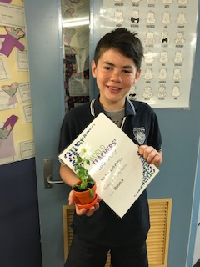**EARN & LEARN**

**We have received our haul of Woolworths Earn & Learn products!**

We accumulated a total of 32,880 points and have spent them on a variety of items to be used by students across all ages.

Thank you to all our families for collecting stickers.

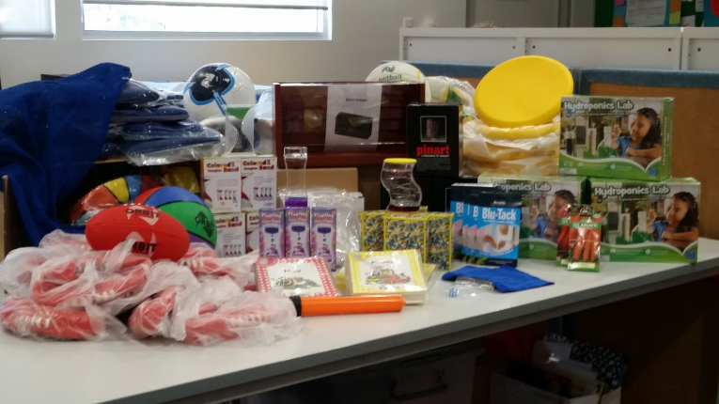

**World Teacher’s Day**



Tomorrow (Friday 25/10) is World Teachers Day. Every day, our teachers are making a positive difference – creating opportunities for their students, empowering minds of young people and proudly teaching our state's future leaders, innovators and influencers.

World Teachers' Day is a wonderful opportunity to celebrate and thank our teachers for the important role they play across our school– inside our classrooms and out in the community.

Celebrated in more than 100 countries world-wide, World Teachers' Day was established by the United Nations Educational, Scientific and Cultural Organisation (UNESCO) in 1994 to recognise the role of teachers in society.

World Teachers' Day is held internationally on 5 October. As the day usually falls during school holidays, Australia holds its celebrations on the last Friday of October each year. Today at assembly we took this wonderful opportunity to thank all of our teachers.

Room 17 visits the **Frank Harding Art Gallery**

**14/10/19**

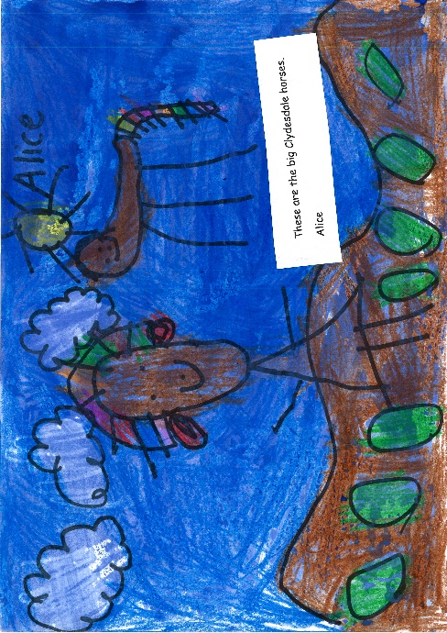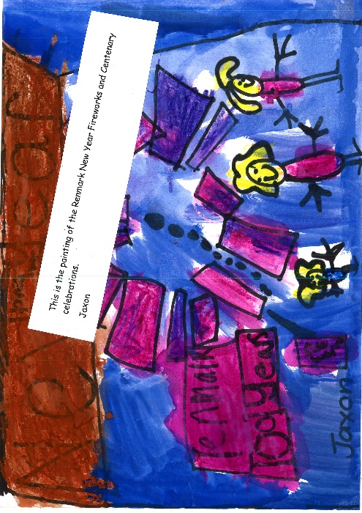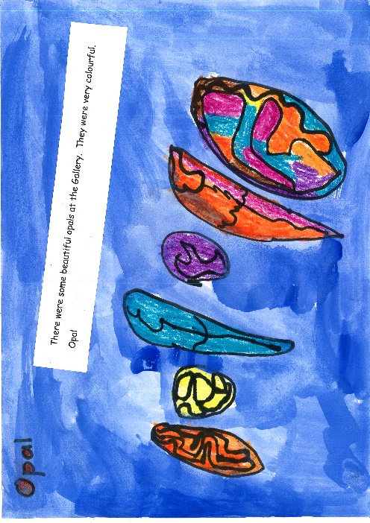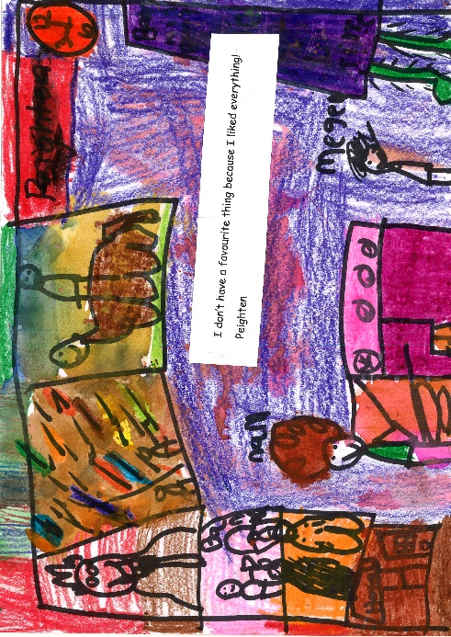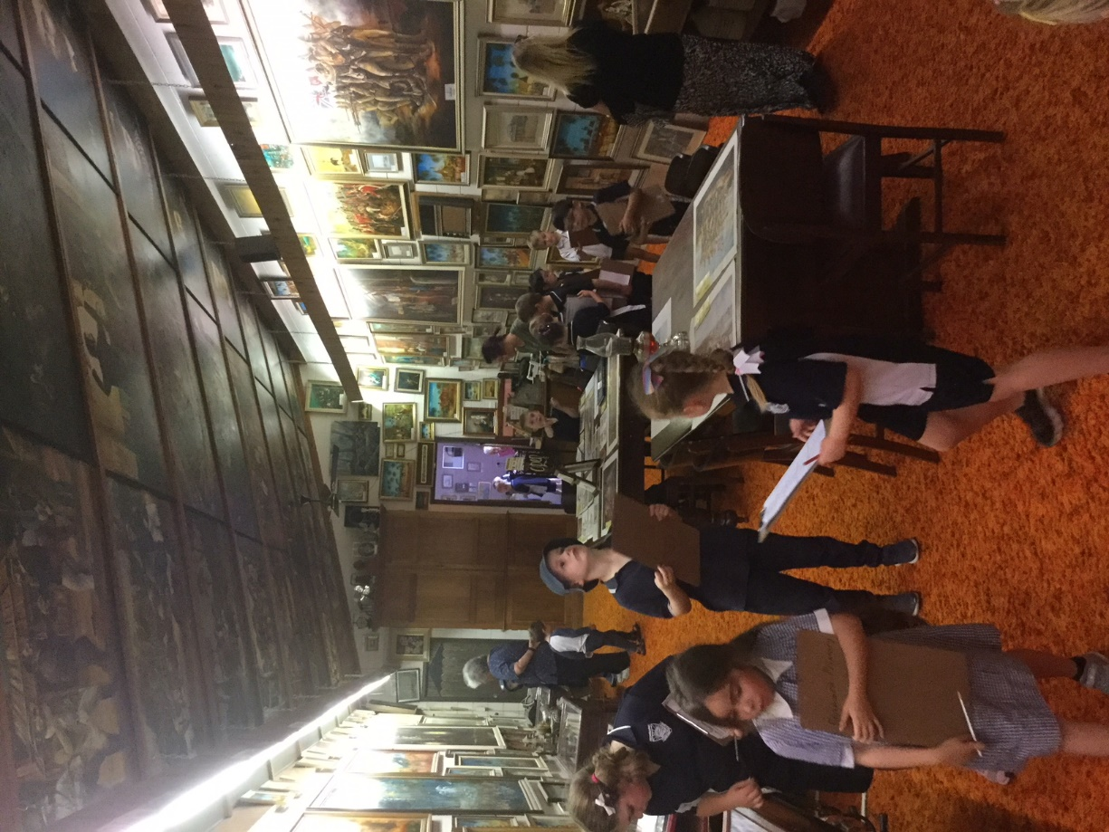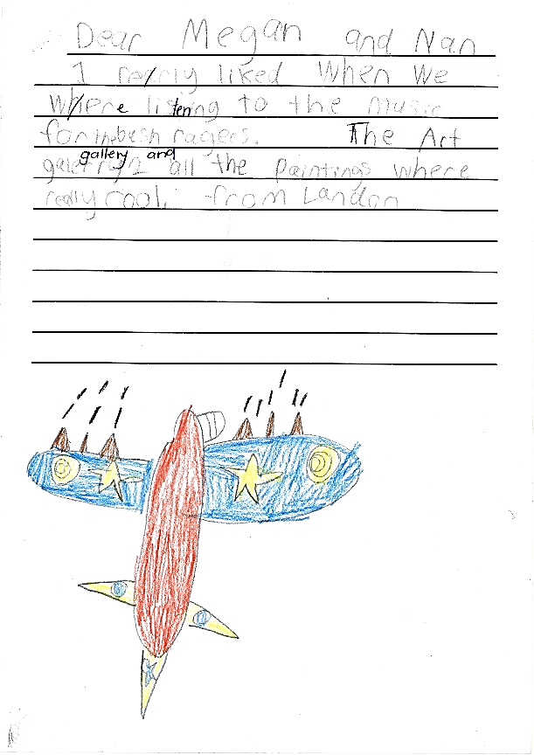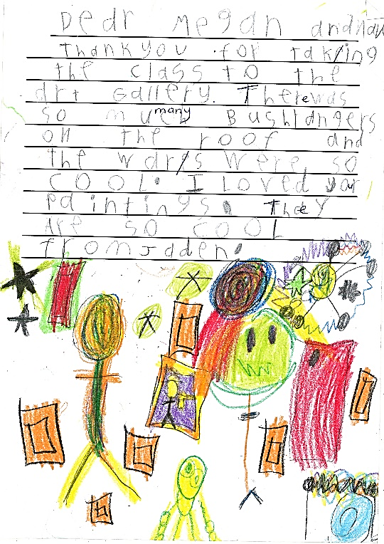

**Thank you letters we wrote to Megan and Nan.**

**Pictures we drew of our favourite part of the gallery.**

**There were lots of amazing pictures to look at - Amber**

**WHAT’S ON ???**

**Dates to remember!**

**Term 4**

**Week 2**

**October 24 Assembly 1.50pm**

**October 25 World Teachers’ day**

**Kindy Familiarisation Visits – Tuesday’s week 3 – 5**

**Week 3**

**October 28 Governing Council 6pm**

**October 29** Kindy Visit 9am –10.50am with the

Parent info meeting at 9.15am

**October 31** Yr. 7 RHS visit 10.50am -1.30pm

**November 1** Instrumental Music Hub Band Tour

**Kindy Familiarisation Visits – Tuesday’s week 3 – 5**

**Week 4**

**November 5** Kindy Visit 9am –10.50am

**NOVEMBER 8 STUDENT FREE DAY**

**Kindy Familiarisation Visits – Tuesday’s week 3 – 5**

**Week 5 and 6**

**November 11 Assembly 10.00am**

**November 11 Remembrance Day**

**November 12** Kindy Visit 9am –11.20am

**Week 7 and 8**

**November 28-29** Yr. 7 RHS Orientation

**November 28** Just2Deadly Awards 2pm (Barmera)

**December 2 Governing Council 6pm**

**DECEMBER 5 LET’S CELEBRATE**

**Week 9**

**DECEMBER 9 YR 7 GRADUATION 2PM**

**December 13 Assembly 2.00pm**

**December 13 Early Dismissal 2.30pm**

**Please Note: Dates are subject to change**

**2019/2020 Term Dates**

**Term 4:** 14 October – 13 December (9 wks.)

**Term 1 2020:** 28 January – 9 April (11 weeks)

**Community notices**

**Riverland Oral Health Centre (school aged dental)** Address: 10 Maddern Street, Berri SA 5343.

Open Monday to Friday 8.30am-4.30pm Phone: 8580 2700.In an emergency or for after hour’s advice call:

1800 022 222.

Dental care is free for most children-SA Dental bulk bill Medicare.

**Renmark Out of School Hours Care**

OSHC opening hours: 6.30am-8.30am & 3.15pm-6.30pm, Pupil free days and School Holidays 6.30am-6.30pm. Please Call: 8586 4481 for bookings.

**National Karate Academies Renmark**

For R-7 at the RPS Hall on Wednesdays (enter from 19th St. Renmark).

Phone Jeff on 0417 938 076.

**Family Activities Program**

Follow the link below to access a fantastic ‘Family Activities Program’ put together by the Renmark Paringa Council.

The Program includes activities suitable for all age groups.

[**http://www.renmarkparinga.sa.gov.au/familyactivities**](http://www.renmarkparinga.sa.gov.au/familyactivities)

[**Fun Fitness Sessions**](https://www.facebook.com/funfitnesssessions/?__tn__=kC-R&eid=ARCnP5a8illogmHGzOWlMvKoLtvQR3q72cEUsTp8NCjlRPtBCzUpQsmH0TkcJU_T453kKqUzVBb0fMr5&hc_ref=ART8pKGk8pfHg_4DTUwDkaBQpwA5hmit28qyT53VM6X7BprzkkugvDybbHPiI21deUo&fref=nf&__xts__%5B0%5D=68.ARDxazeWnjlM7l55dEYdQwoWG0tDV3nNNGglFWnqEGJueSmv81zNnWIfAgqVIz-HUHITMRM5lT0uykn7aYFsUCupZDsVXEUaH8mXrv8LeaPGm5bZNeuj_5kO0O9NVxqvtj29nixVVaxwVoJmEWUIa-9HgiMsYdzbmyjNVP6g6rYVdYXGbQDv2nMwKfqx0v0iLcLV58FTMsjffX_gRpKsO2FX4HdR-ZflZmflK6kN1CapLZqxNjm1sLMgjxP5B9KQrrOJaTpNPUavMtIVZVtNMvKFVmzH5a6HaMWfSQ7aHaXXklJUipJRicG6KKQJo7un5nYluI0nuefYvuefbEwJf2KmiynO) EVENINGS ARE BACK! - Commencing 24.10.19 Thursday’s 6.30-7.30pm at the **Renmark High School COLA**.

$5 per session. Tell your family, friends & team mates!

**Don’t forget to check out our NEWLY UPDATED School website @** [**http://www.renmarkr7.sa.edu.au**](http://www.renmarkr7.sa.edu.au)



And****

**Renmark Primary School – Official**





